Lab: Multi-Cluster Deployment with Argo CD using ApplicationSets
We will create
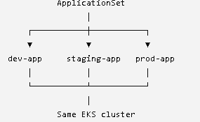
For this first lab, dev/staging/prod are logical environments, not three physical EKS clusters.

Step 1 — Go to your Git repository
On EC2:
cd /home/ubuntu/flipkart-gitops
Verify:
pwd
You should get:
/home/ubuntu/flipkart-gitops
INSTALL APPLICATION SET CRD(Custom resource definition):
kubectl apply --server-side --force-conflicts \
-f https://raw.githubusercontent.com/argoproj/argo-cd/v3.5.2/manifests/crds/applicationset-crd.yaml
Verify:
kubectl get crd applicationsets.argoproj.io
Step 2 — Create a new directory
Create:
mkdir -p appsets
Check:
ls
You should now have:
Apps
appsets
child-apps
root-app
Step 3 — Create the ApplicationSet
Run:
nano appsets/multi-env-product.yaml

apiVersion: argoproj.io/v1alpha1
kind: ApplicationSet
metadata:
name: product-multi-env
namespace: argocd
spec:
generators:
- list:
elements:
- environment: dev
namespace: product-dev
- environment: staging
namespace: product-staging
- environment: prod
namespace: product-prod
template:
metadata:
name: 'product-{{environment}}'
spec:
project: default
source:
repoURL: https://github.com/letslearn207/flipkart-gitops.git
targetRevision: HEAD
path: apps/product
destination:
server: https://kubernetes.default.svc
namespace: '{{namespace}}'
syncPolicy:
automated:
prune: true
selfHeal: true
syncOptions:
- CreateNamespace=true

Commit and push
Because Argo CD is using Git as the source of truth:
git add appsets/multi-env-product.yaml
Then:
git commit -m "Add multi environment ApplicationSet"
Then:
git push origin main
Now GitHub contains our ApplicationSet.
Apply the ApplicationSet
Now we tell Kubernetes/Argo CD about the ApplicationSet.
Run:
kubectl apply -f appsets/multi-env-product.yaml
Expected:
applicationset.argoproj.io/product-multi-env created
Notice something important:
We applied ONE ApplicationSet.
We did not manually create:
product-dev
product-staging
product-prod
The ApplicationSet controller will generate those Applications.
Check the ApplicationSet
Run:
kubectl get applicationset -n argocd
You should see:
NAME AGE
product-multi-env ...
Check generated Applications
Run:
kubectl get applications -n argocd
You should now see something like:

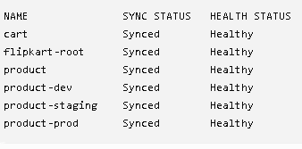
#if you are unable to see the proper output then:
kubectl rollout restart deployment argocd-applicationset-controller -n argocd
kubectl rollout status deployment argocd-applicationset-controller -n argocd
kubectl get applications -n argocd
Check the namespaces
Run:
kubectl get namespaces
You should see:
product-dev
product-staging
product-prod
Because we specified:
syncOptions:
- CreateNamespace=true
Argo CD creates the destination namespaces automatically.
Check the deployments
Run:
kubectl get deployments -A
You should see Product deployed in three namespaces:
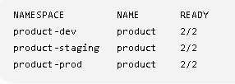
So we have:
